**Group A**

**Lab Assignment 1c**

### **BDM 1024 - Data Technology Solutions**

Install Hadoop on AWS

1)Create an instance of Ubuntu Server using Amazon EC2 and connect it to Putty

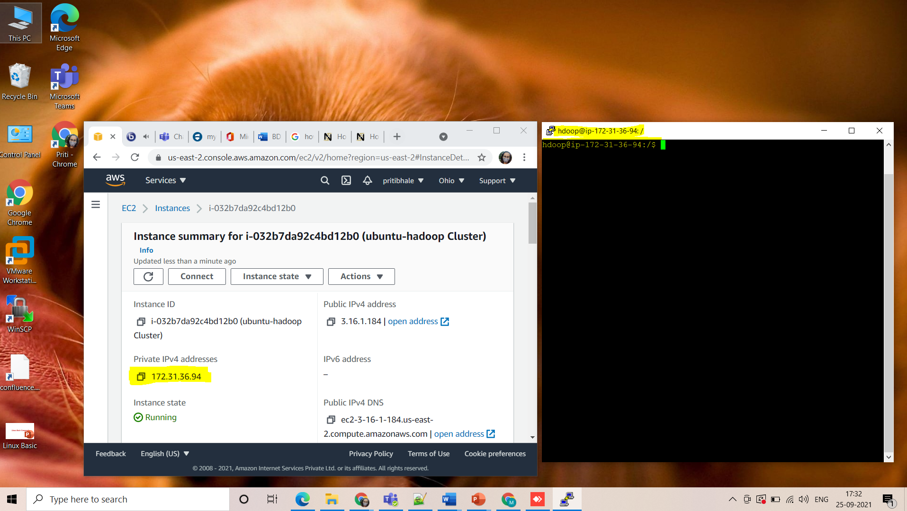

2)Format HDFS file system on NameNode :

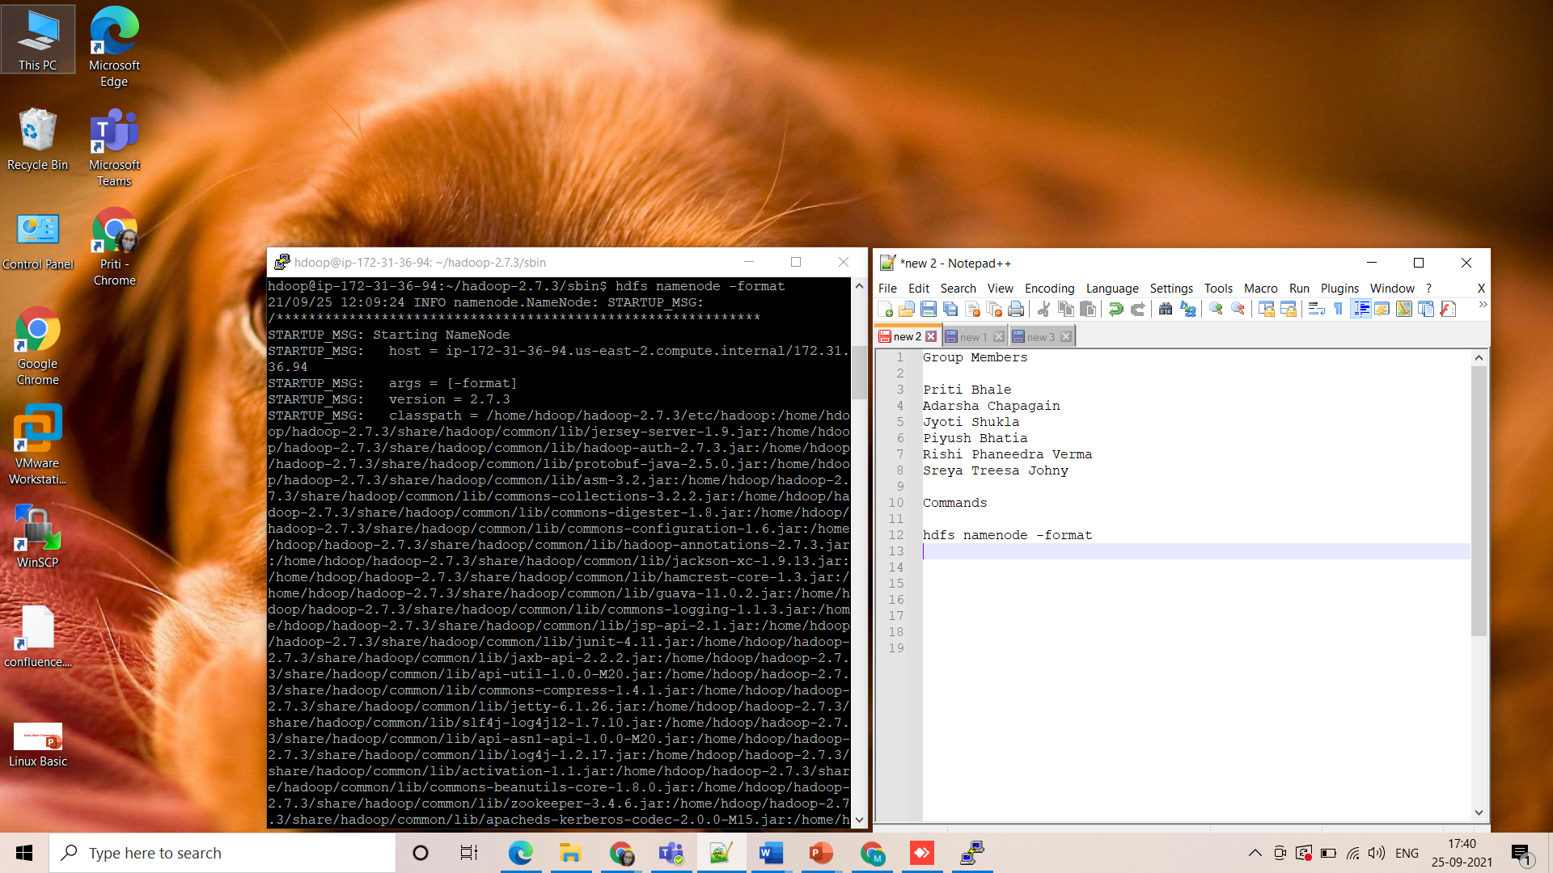

3) Type command **start-dfs.sh** and **jps** to check if all the daemons are active and running as Java processes

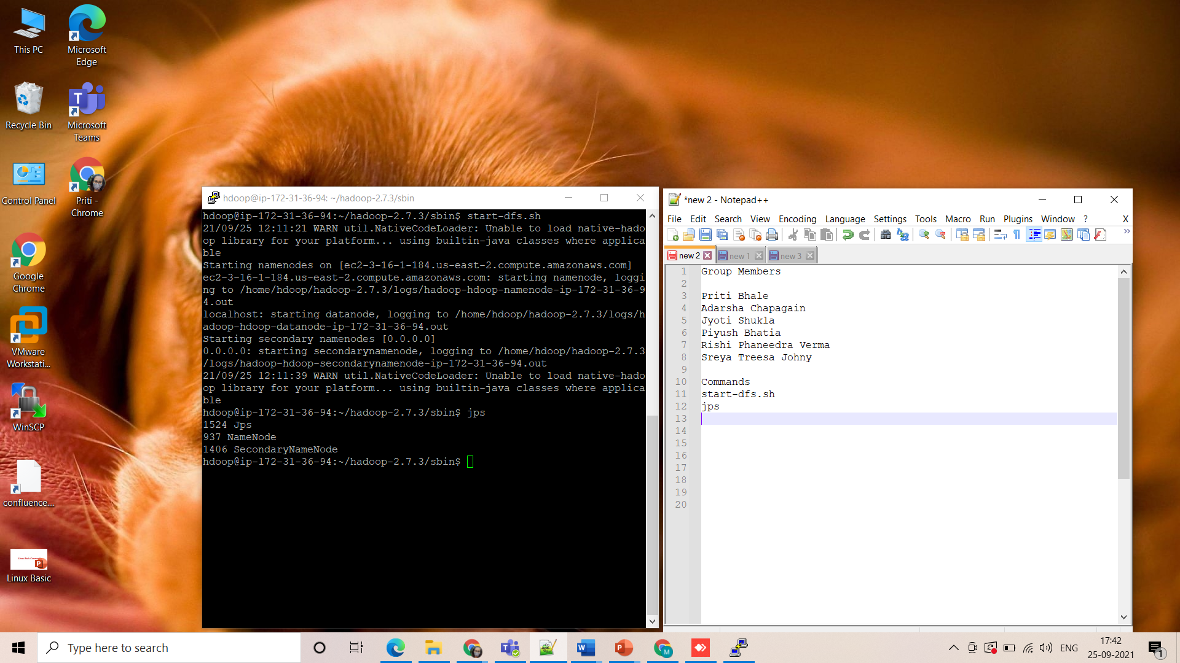

4) Type command **start-yarn.sh** and **jps** to check if all the daemons are active and running as Java processes

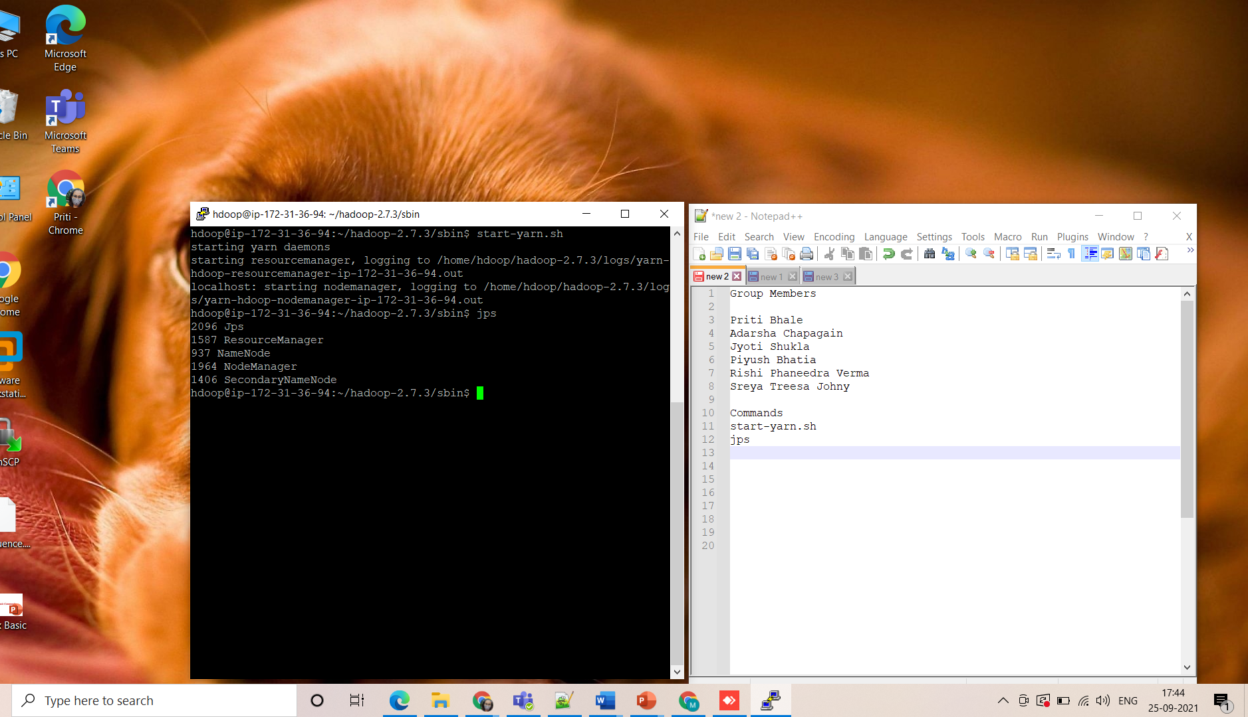

5) Check if the commands are working properly

Commands executed:

**hdfs dfs -mkdir**

**hdfs dfs -ls**

